Code Analyzer

Installation Manual

Publication Date: April 2014

Version: 0.99b

©2014

Java is a registered brand of Oracle Corporation.

The UEM logos are property of “Universidad Europea de Madrid” which belongs to the “Laureate International Universities” group. All rights reserved.

This document is provided ‘As it is’. The information that this document contains including URL’s and other references to Internet websites, may change in the near future.

[Creative Commons License](http://creativecommons.org/licenses/by-nc-sa/4.0/)

Code Analyzer by David H. and bensteUEM is licensed under a [Creative Commons Attribution-NonCommercial-ShareAlike 4.0 International License](http://creativecommons.org/licenses/by-nc-sa/4.0/).  
Based on a work at <https://github.com/bensteUEM/uem.basesDeDatos.hernandezstein>

Contents

1. Java 8 Installation 4

Step 1 – Downloading Java Development Kit 8 4

Step 2 – Installing Java Development Kit 8 4

2. Code Analyzer Installation 5

Step 1 – Download the program 5

Step 2 – Uncompress the file **Error! Bookmark not defined.**

Step 3 – Run the program 5

# 1. Java 8 Installation

In order to run this software, it is fully recommendable to have installed Java Development Kit 8 (JDK 8) or at least Java Runtime Environment 8 (JRE 8). If the computer administrator has already installed this Java version, please continue reading section 2.

In this section, it will be explained how to download and install Java Development Kit 8. The installation of the JDK 8 includes JRE 8. Please notice that in order to perform the following steps, the computer user must have administrator rights.

## Step 1 – Downloading Java Development Kit 8

Enter the computer Internet browser and go to the following URL:

<http://www.oracle.com/technetwork/java/javase/downloads/jdk8-downloads-2133151.html>

Accept the “Oracle Binary Code License Agreement for Java SE” and click the appropriate version of Java 8 for your operating system in the “Download” column:

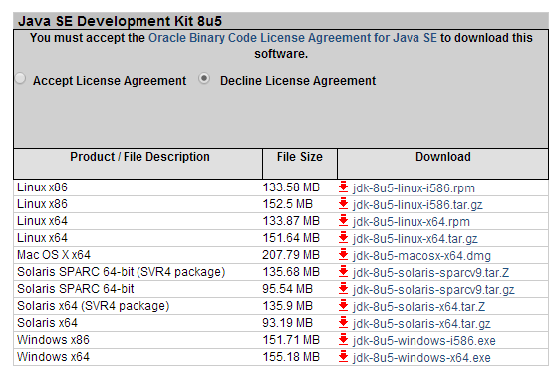

Please, wait until the download finishes.

## Step 2 – Installing Java Development Kit 8

Once the download finishes, double click the downloaded file. A window will appear. In this window, the administrator user should click “next”, select what components should be installed and wait until the installation finishes.

# 2. Code Analyzer Installation

This program does not need a classical installation. However in this section, it will be explained how the final user can run the program.

## Step 1 – Download the program

In order to download the Code Analyzer program please visit the following link: <https://github.com/bensteUEM/uem.basesDeDatos.hernandezstein/releases> Once there, download the latest “CodeAnalyzer_vx.xx.jar” file. At the end of this process, there should be a .jar file in the final user computer.

## Step 2 – Run the program

Locate the “CodeAnalyzer_vx.xx.jar” downloaded file and double click it, the program will then run.

Please remember: If the final user computer does not have installed the Java Development kit 8 or at least Java Runtime Environment 8, this program might not work properly.